

User Manual – Version 1.1

March 2021

# Acknowledgements

Developers/Contributors:

* Mike Moger (meanmedianmoge)
* John Breton (Ellipses22)
* Jonathan H. (djigneo/apparent1)
* Rob S. (smithrobs)
* Matthew A. (mtallen)
* Alex M. (qckpckt)

Special thanks to those who submitted user stories:

* Christopher H. M. Jacques (chmjacques)
* Jesse (juicynoisebits)
* Jeremy (Red Means Recording)
* Scott (Sound Isles)
* Ian (collector//emitter)

Additional thanks to our beta testers and those who submitted bugs or feature requests ahead of this release:

* nissane
* luciusbono
* personalnadir
* Emptydroid
* AvantGov
* barkinggecko
* rogueblue42
* p1afff
* devilsinkpot
* theconsultantde
* hickscorp
* Arxi

And lastly, a huge appreciation to the entire Empress Effects team for the support and assistance in developing this application!

# 

# EULA

This software is distributed under GNU General Public License 3.0. Please familiarize yourself with the Terms & Conditions of copyleft licenses like GPL (and others) here: <https://www.gnu.org/licenses/gpl-3.0.en.html>. ZOIA and its patch binary format are a trademark of Empress Effects, Inc and are used with permission. Neither the developers nor Empress Effects, Inc. are liable for any issues caused or raised by the use or modification of this application. By installing the application you agree to these terms. All source code, documentation, issue reports, and release candidates are hosted via Github: <https://github.com/meanmedianmoge/zoia_lib>.

# Table of Contents

Acknowledgements **1**

EULA **1**

Table of Contents **2**

Welcome **3**

Loading the App

Tabs

PatchStorage View **4**

Patch Metadata

Searching

Downloads

Refresh Patch List

Local Storage View **6**

Check for Updates

Export and Delete

Version Histories

Editing Patch Metadata

Patch Visualizer

SD Card View **10**

Selecting the SD Location

Managing SD Directories

Moving Patches

Import Functions

Setting the Export Directory

Bank View **13**

Local Storage table

Moving Patches to a Bank

Bank Operations

Additional Features **15**

File Menu

Sort Menu

Options Menu

Help Menu

Documentation

Changelog **17**

New Features

Bug Fixes

Known Issues

Future Plans **18**

# Welcome!

Welcome to the ZOIA Librarian! The Librarian aims to make using ZOIA much easier. Whether you are a major patch creator or a general ZOIA user, the ZOIA Librarian has features that can help anyone organize and manage their patches.

After you have downloaded and installed the ZOIA Librarian, the application can be launched from an executable on Windows or application file on OSX. Double-clicking on ZOIALibrarian.1.1.exe or ZOIALibrarian.1.1.app file will start the app. You will be greeted with a brief splash screen as the application loads.

*If this is your first time launching the application, the start-up process will take longer than usual, as all patch information is retrieved from PatchStorage. Subsequent start-ups will not need to retrieve as much information, significantly improving the loading time.*

The application is split into 4 main tabs.



These tabs allow you to navigate between different features of the Librarian. The following sections of this manual will focus on each tab and explain the features specific to that tab:

* PatchStorage View is where you quickly browse and search through all ZOIA patches that are currently hosted on PatchStorage. All patch notes and meta-data from the site are included, giving you a convenient way to explore and download interesting patches along the way.
* Local Storage View is where you can view and edit all of the patches in your local library. Update the tag information for patches, explore groups of patches that were saved together as Version Histories, and see the details of each patch as if you were using your ZOIA with the Patch Visualizer.
* SD Card View is where you manage the folders and patches on your SD card. Reorder the patches within each SD card folder without hassle and import multiple patches at once for simplicity.
* Banks View is where you can easily create banks of patches, ready to be exported to the SD card. Drag-and-drop multiple patches at once from your local library, move them around, and save for a dynamic way to handle multiple SD folders.

# PatchStorage View

The PatchStorage tab is where you quickly browse and search through all ZOIA patches currently hosted on PatchStorage. On the left side of the screen, you will find a table containing information about every patch currently available on Patchstorage, including the title, user tags, categories, and the date the patch was uploaded or last updated.

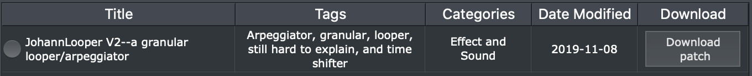When you select a patch by clicking on the circle beside the patch title, the right side of the screen will populate with additional information about the patch. This displays the author and license, the like, view, and download counts, and can even include a clickable 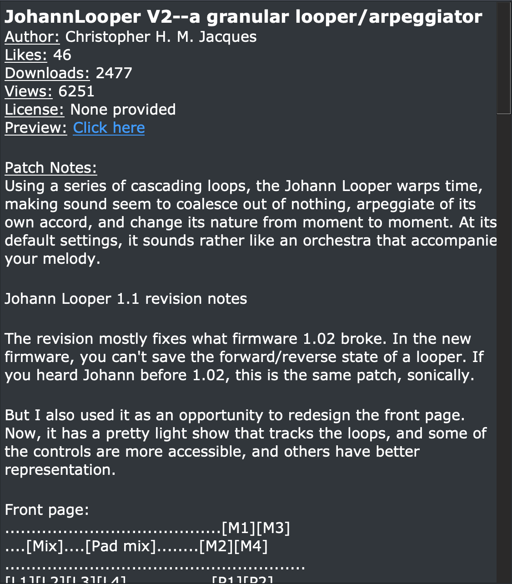preview link (if the author has included one).

Above the table on the left, there is a search bar. You can search for patches by title, tag, category, and date in the PatchStorage View tab. To initiate a search, enter the query you want to search for and hit Enter/Return.

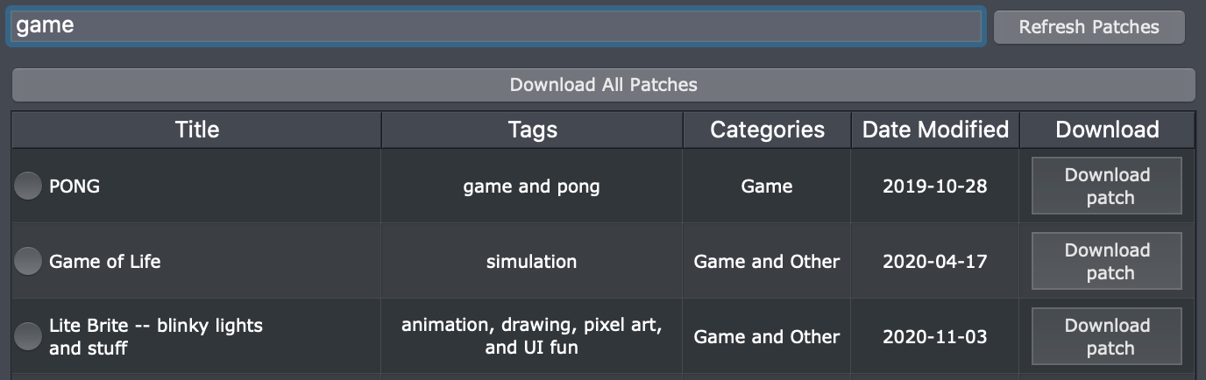Downloading patches is as easy as hitting the download button to the right of the patch you want to download. Once the download is complete, this button will disappear so that you do not accidently download the same patch twice. Even on subsequent launches of the application, if you have previously downloaded a patch and it still exists within a Librarian, the button will not appear.

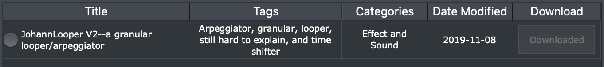To the right of the search bar, there is a “Refresh Patches” button that will allow you to refresh the patch list to reflect the patches currently available on Patchstorage. The app also updates this list each time it is opened. If you refresh the list, a pop-up will let you know when it has finished.

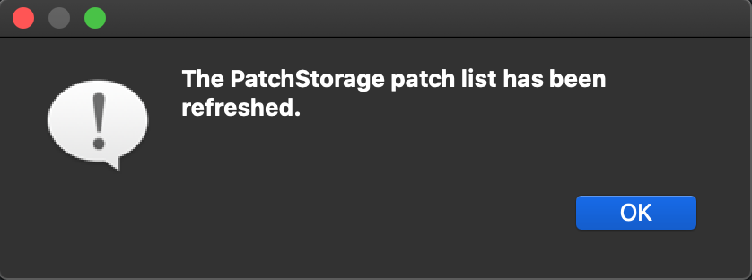Above the search bar is the “Download All Patches” button, which will download all currently hosted patches from PatchStorage. Note that this download process is very time-consuming.

You can view all the patches you have downloaded by switching to the Local Storage tab, which will be covered in the next section.

# Local Storage View

At first glance, the Local Storage tab will look very similar to the previous tab. However, there are many additional options to explore. Searching behaves the same as it does in the PatchStorage tab, except you can now also search for patches by author. Additionally, there are two new buttons to the left and right of the search bar. A “Back” button and a “Check for updates” button. The “Back” button will initially be inaccessible.

The “Check for updates” button will automatically check all the patches you have within the Librarian to see if they have been updated on PatchStorage. If the patches have been changed, these updates will automatically be retrieved and saved. Most of the time, however, this is the message you will get when clicking the button.

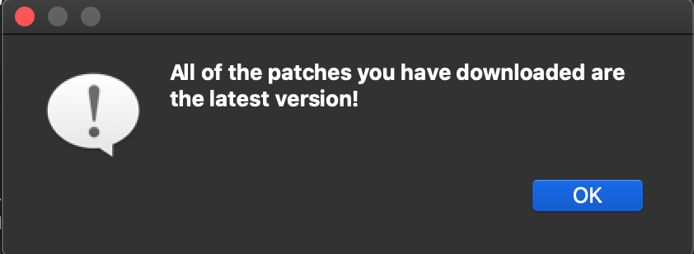Within the patch table, there are two additional options (Export and Delete) and a ticker (Rating). To delete a patch from the Librarian, click the “X” button beside the patch.

When you click on the export button for the first time, the message below is most likely what you will see. If you click “OK”, you will be able to select the SD card used for patch transfer. Alternatively, to select your SD Card location, look for the “File” option on the taskbar at the top of the screen, click it, and then click “Specify SD Card Location”.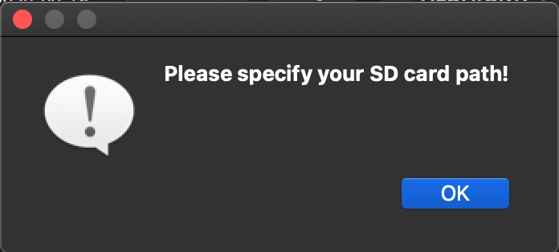

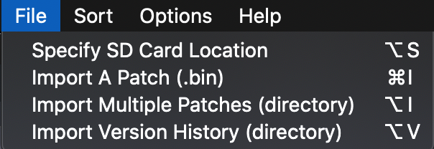By default, exporting from the Local Storage tab will export patches to a folder called “to_zoia”. You can choose a different directory location and view the exported patches in the SD Card tab.

When you export a patch, the application will detect if there are patches in the directory already and initialize the window selection with the next-available slot number. You will be warned by a pop-up if 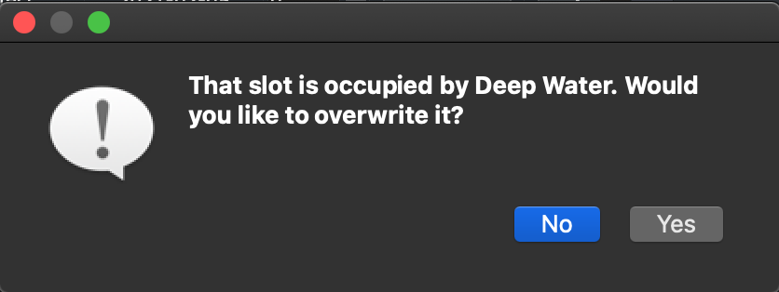you try to overwrite an existing patch.

Certain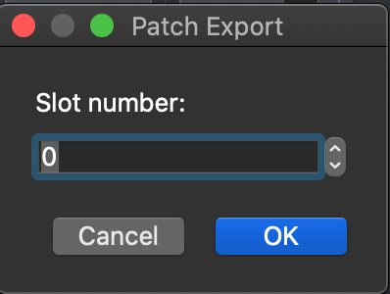 patches are labeled as “[Multiple Versions]” - these originated as a collection of multiple patches, either downloaded from PatchStorage or mass-imported from the SD card. Instead of requiring a unique patch id, the Librarian groups these patches together, each one as a different version. You can export an entire version history by clicking “Export patches”, or delete all patches within by clicking “X” on the row.

Exporting an entire Version History to the SD card may require a lot of overwriting of patches, or it may not fit all of them without altering the slot number.

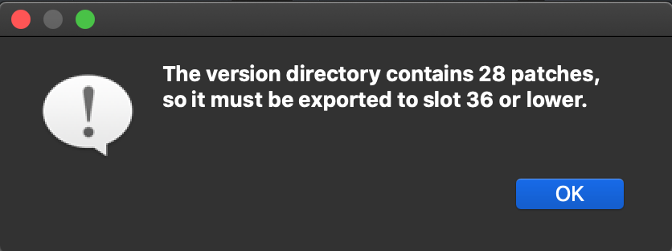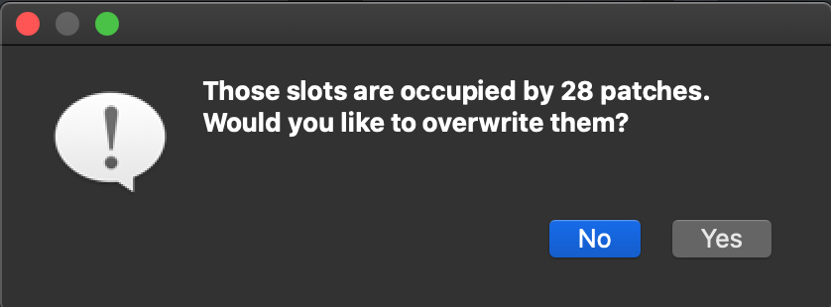To access the Version History view, click on any patch that has “[Multiple versions]” in its name. Upon entering the Version History view for a patch, you can individually rate, 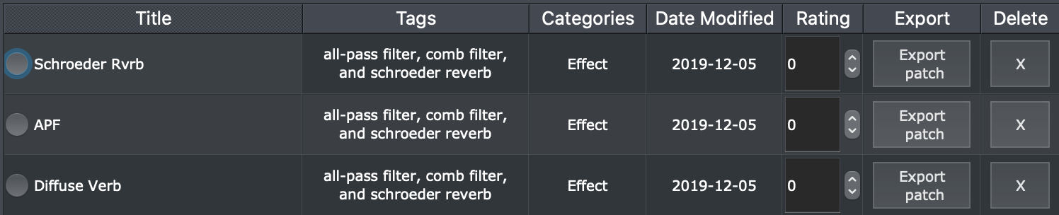export, and/or delete specific versions. To exit this view, click the “Back” button.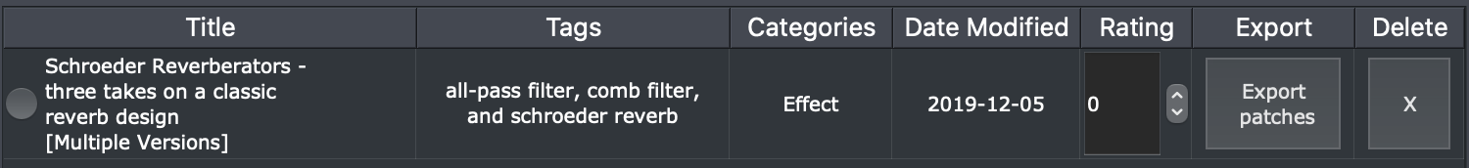

The Local Storage tab also offers edit functionality for patches you’ve downloaded or imported. To modify the patch tags or categories, simply double-click on the cell you wish to edit and start typing. Once you have finished, click elsewhere in the application or hit Enter/Return.



A new feature that has been added is the ability to rate patches in Local Storage, on a scale from 0 to 5. Either use the up/down arrows or double-click the box and enter your rating. Ratings can be applied for an entire version history as well as individual patches.



The right-side upper panel displays the patch metadata, which can also be edited. To do so, first select a patch on the left-hand side of the screen by clicking on the circle to the left of its name, then make the edits you wish to add or remove.

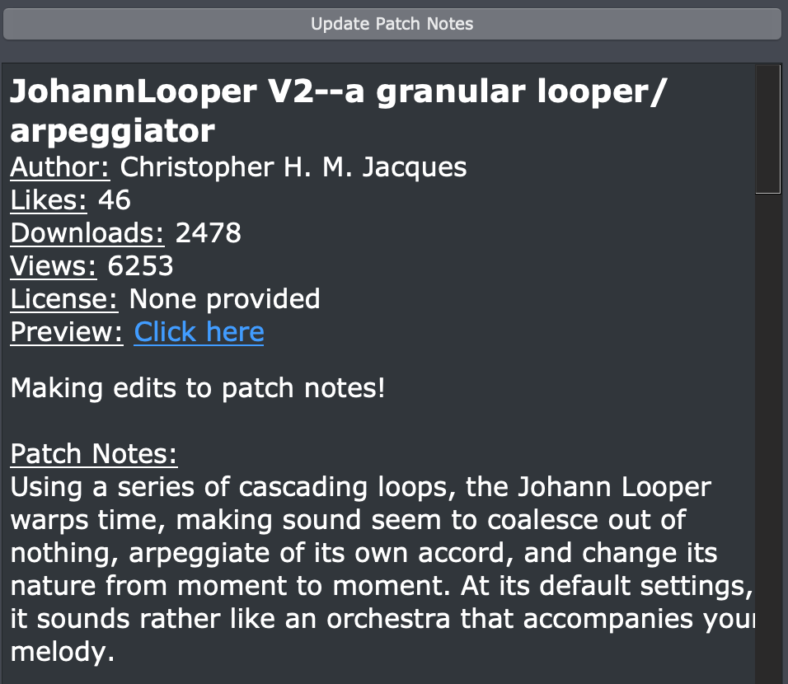Once you are done, click the “Update Patch Notes” above to save these changes. Two notes about making edits to patch notes or information:

* All headers in the patch notes can be modified.
* Tags and categories cannot be mass modified for patches that contain multiple versions, however each version can have their tags and categories individually modified.

The last major feature in the Local Storage tab is the Patch Visualizer. Located in the right-side lower panel, the visualizer offers a way to explore the layout of a patch before loading it onto your ZOIA. There are two primary types of information present in the visualizer:

* Patch - displays the Patch name, estimated CPU (not including connections), I/O, MIDI channels, stomp-switches used, the number of pages, and the number of starred parameters.
* 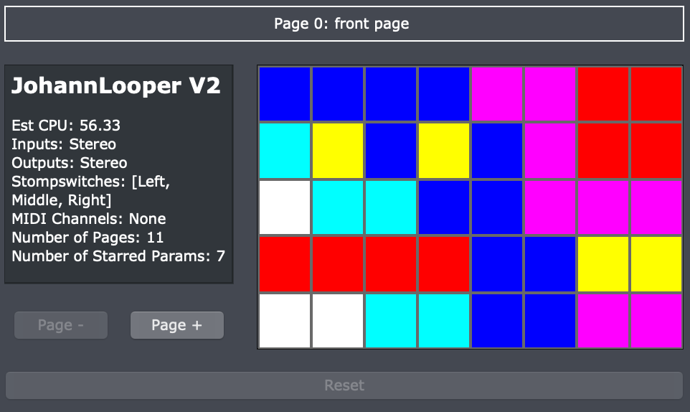Module - displays the module name, type, options chosen, parameter values, starred parameters (plus the MIDI CC if assigned), and outgoing connections.

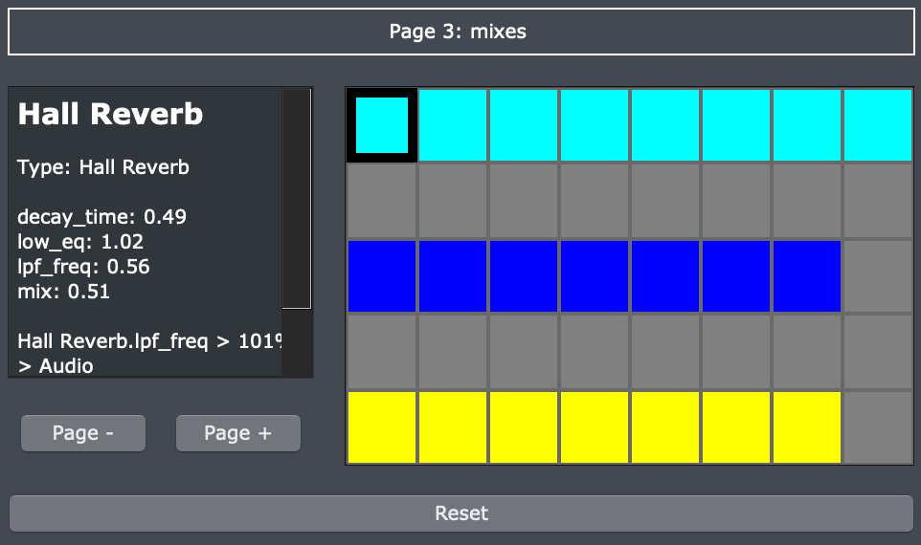Please note that certain patches may fail to display in the visualizer panel - this is likely due to them being saved on deprecated ZOIA firmware. If you find a patch that doesn’t display a visualization as-is, an easy fix is to load it onto your ZOIA, save with a more recent firmware (preferably 2.0), and re-import the patch (deleting the old version in the process).

Now that we have explored the Local Storage tab, it’s time to move on the SD Card tab.

# SD Card View

The SD Card tab allows you to inspect the directories located on the SD card you have specified. In case you have not specified your SD card yet, look for the “File” option towards the top left of the screen, click it, and then click “Specify SD Card Location''. After selecting your SD card location, this is the screen you will be presented with.

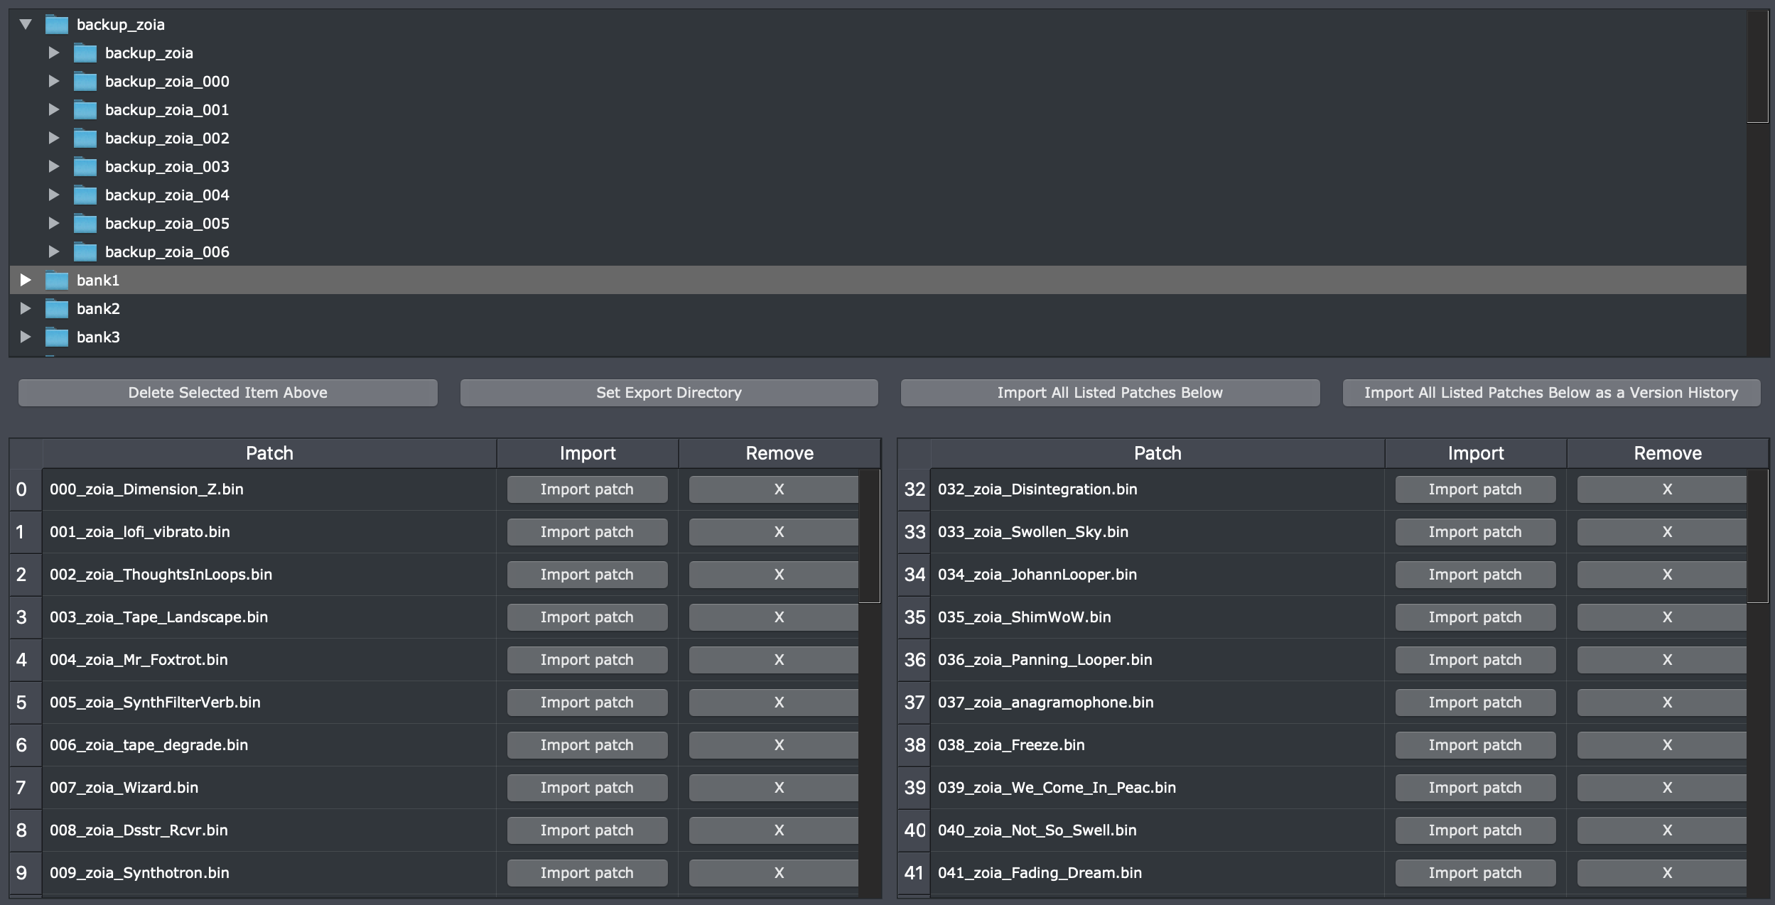

The upper portion of the screen lists all the folders located on the SD card. You can expand any of these folders by clicking on the arrow to the left of each folder. Clicking a folder will populate the table below with patches.

You can move patches within the folder by dragging and dropping them into different slots on the SD card. Multiple selections can be made with Shift or Ctrl/Cmd macros. You can also remove a patch from your SD card by clicking the “X” button in each row, or completely remove a directory from your SD card by selecting “Delete Selected Item Above”. This button will trigger a confirmation window.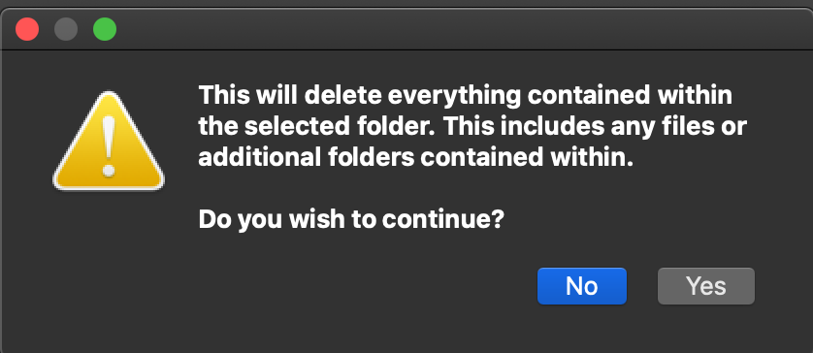

The most useful features in the SD Card tab relate to importing patches into Local Storage. There are three options available. The first is achieved by clicking “Import Patch” next to a patch in the above table. The second and third options apply to importing multiple patches at once. Multiple patches can be mass-imported in one of two ways: as individual patches, which simplifies the steps to import every patch in a given SD Card folder, or as a Version History, for a group of similar patches or ones you wish to treat as a collection.

When the Librarian imports patches, it will attempt to merge patches with the same name as the patches that you have in your Local Storage or ones currently hosted on Patchstorage. This process has two benefits:

* If the imported patch differs from the version in Local Storage, it creates a Version History with the original and new version(s) so you can compare them.
* If the imported patch is one you received from PatchStorage but haven’t downloaded yet through the Librarian, it will copy over the patch notes metadata from the site, saving you from having to manually enter that information.

If an exact copy of a single imported patch already exists in your Local Storage, it will not be imported, since there is nothing new to save.

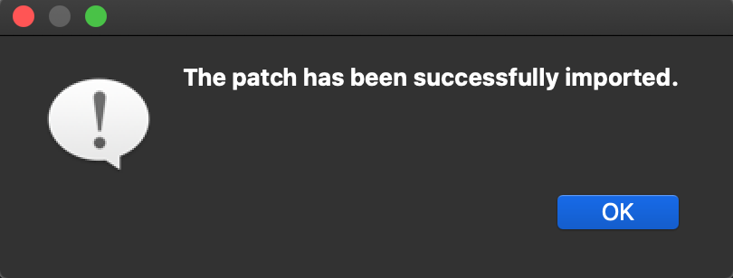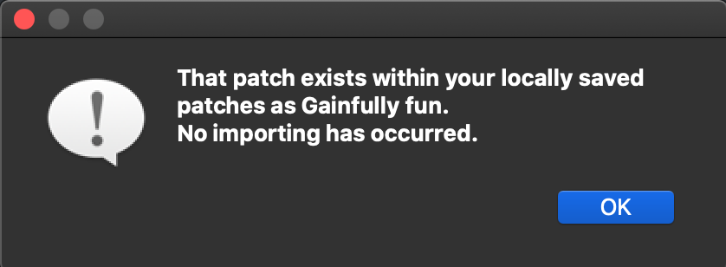For individual multiples, the import process will save anything without duplicates, and the pop-up will display the number of success and failures. Clicking “Show Details” will list off the names and locations of the exact copies using a [Version History: Patch] naming scheme. If a patch you’re attempting to import 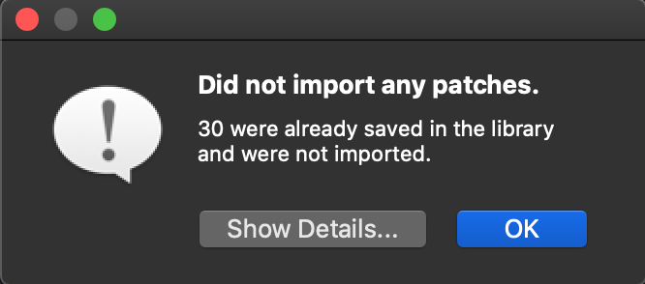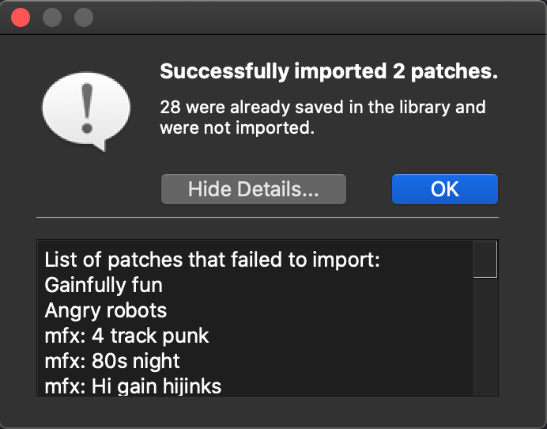does not exist within a version history, it will just have the patch name by itself.

For version imports, the process attempts to create a Version History from multiple patches. There is a caveat here - a version history is meant to be completely unique from individual patches, so any patches in the SD Card directory which exist as individuals will not be included in the resulting history. The pop-up message will detail the failing patches and whether a new Version History was created.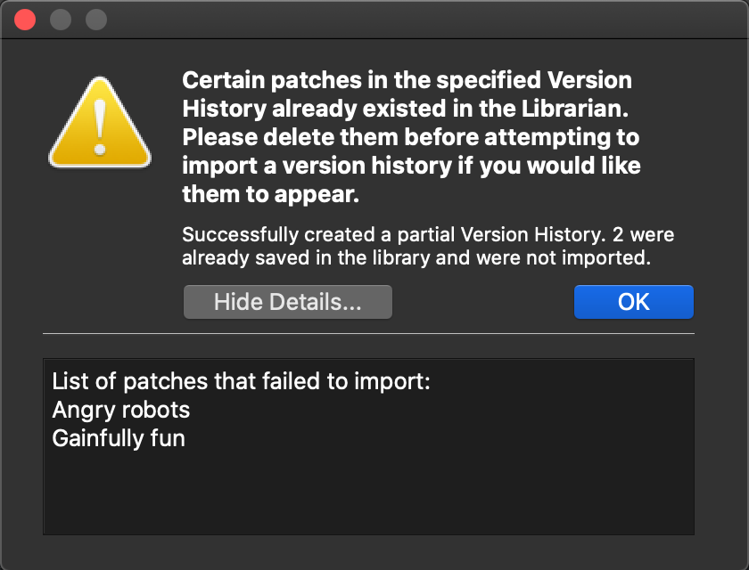

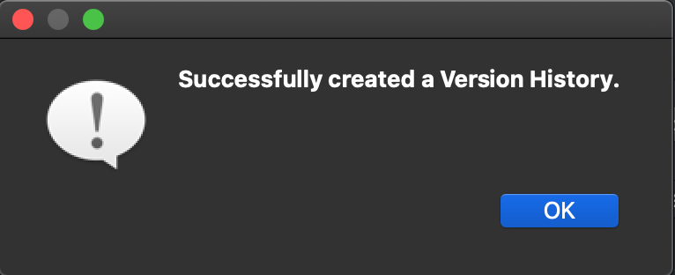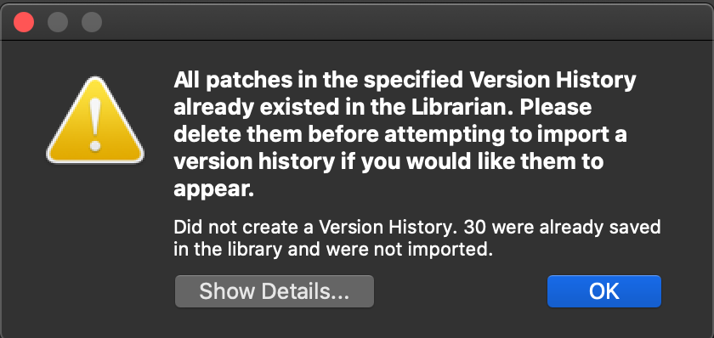Finally, the newest button is “Set Export Directory”, which sets the patch export destination directory for the SD Card used by Local Storage. By default this is set to “to_zoia”. It will bring up a directory select window and then confirm the decision.

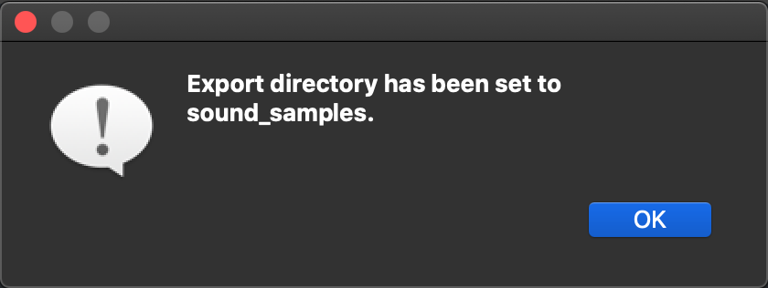The SD Card tab gives you a quick way to mass import patches from your SD card into the Librarian, but what about mass exporting? That is where the Banks tab comes into play, which will be discussed in the next section.

# Banks View

The Banks tab offers a way to work with banks, or collections of patches, both on and off of the SD card.

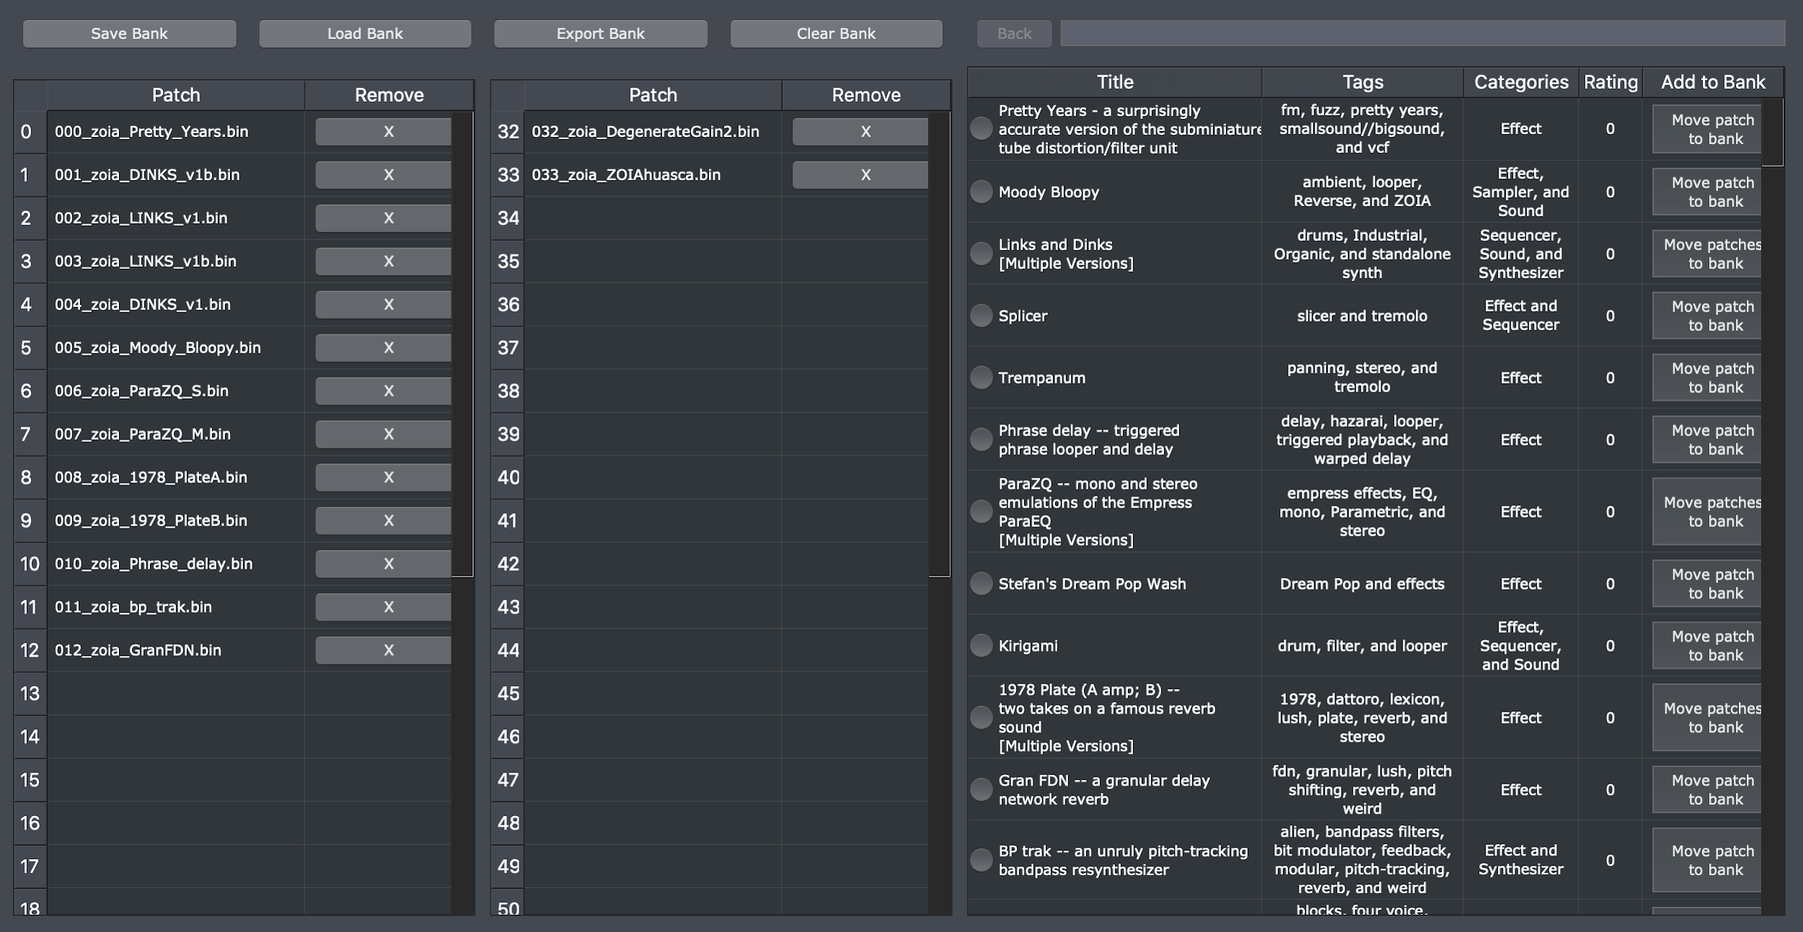

The right side of the screen displays the patches saved within the Librarian. Unlike the Local Storage tab, you cannot modify the patch tags, categories, rating, or patch notes in this view, nor can you delete them. You can, however, still view additional patch information and enter the Version History for patches in the Banks tab. You can also search for patches just as you can in the Local Storage View.

To get started, select a patch from the Local table, and either drag it over to a slot in one of the two bank tables, or click the “Move patch(es) to bank” button for the patch. Once you have patches in the bank tables, you can move them around in the same way as the SD Card tables. If you add a patch to the bank that has multiple versions contained within it, it will automatically populate the table with all the patches contained within.

When you finish making your bank, you can save it using the “Save Bank” button, and/or export it using the “Export Bank” button. Please note exporting cannot occur unless you have specified a SD card location. Whether you are saving or exporting, you will be asked to provide a name for your bank, with an extra confirmation window if the name you select already exists as a bank.

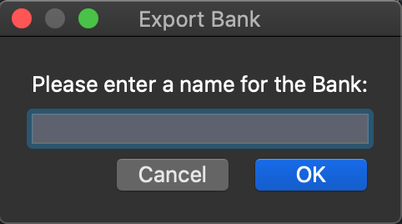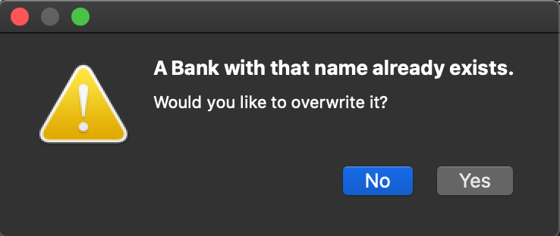Once your bank(s) are saved, you can use the “Load Bank” button to populate the bank tables with those patches. If you remove patches from your Local Storage that are within a saved bank, they will not load, as they no longer exist on your computer.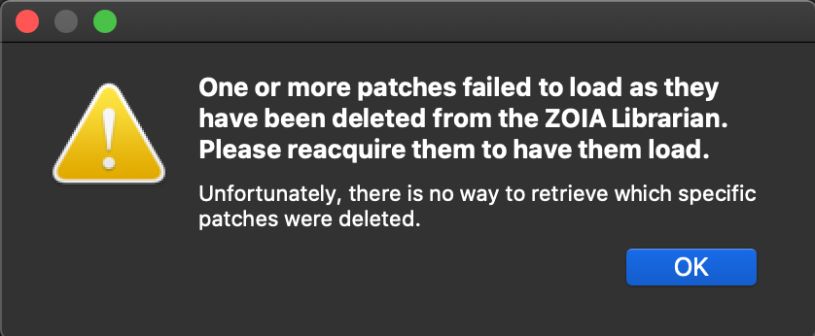

Finally, there is a “Clear Bank” button, which will quickly clear the bank completely (alternatively, you can remove patches from a bank by clicking the “X” button in each row).

That concludes the main functionality within the ZOIA Librarian. The final couple of sections will discuss additional features and what to expect in future versions.

# Additional Features

There are some additional features that are available in the Librarian which can apply to multiple tabs. You’ll find these in the menu actions.

The File menu has been discussed previously, in the context of your SD card location. The other items are for when you’d like to import patch files that exist on your local filesystem. Each one is analogous to the functionality in the SD Card tab.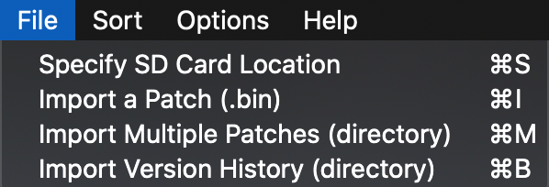

The Sort menu offers ways to sort the various tables in the Librarian. This applies to the PatchStorage, Local Storage, and Bank tabs. Note that sorting by Author is not available in the PatchStorage tab. The default sorting option is by Date (New-Old).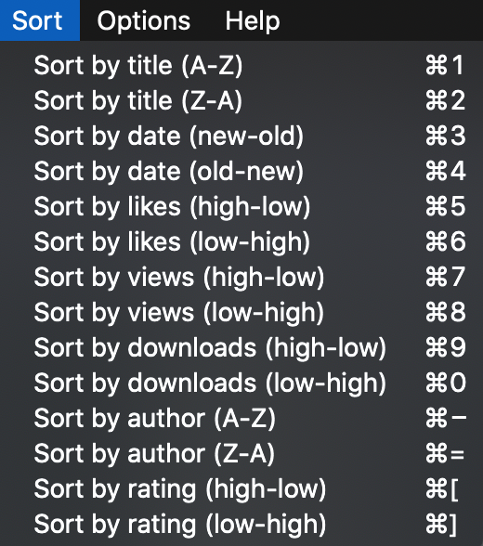

The Options menu is for altering the look and feel of the Librarian, including row inversion, font style and size, dark mode toggle (always on, of course), and a way to reset the UI panels and tables to their defaults.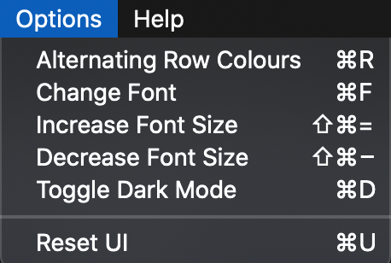

The Help menu is where you’ll find documentation for the Librarian and resources for using the ZOIA. This information will display in the PatchStorage tab on the right-side panel where the patch notes would show. The FAQ is provided below as an example.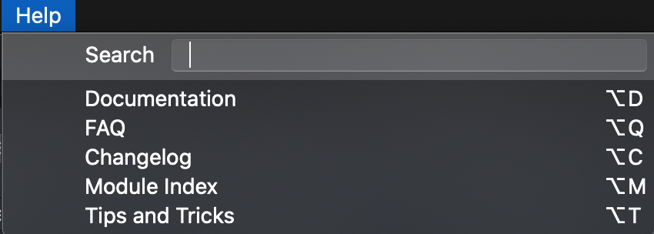

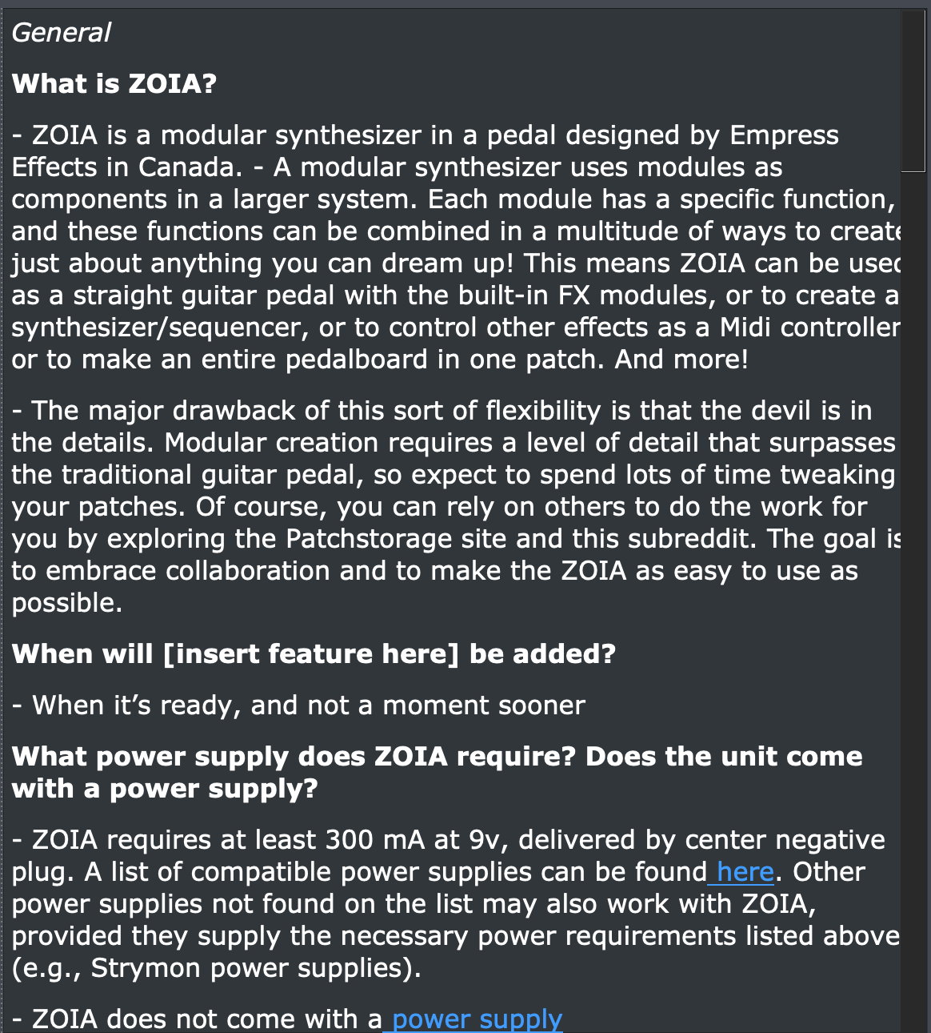

# Changelog

Version 1.1 represents the first major update of the Librarian and includes many notable additions, changes, and bug fixes.

New Features

* The visualizer panel has received a few upgrades, including:
  + Calculate and display the correct number of blocks per module.
  + List the actual parameter names, with their values scaled from 0 to 1.
  + Adjust the connection text to be more readable.
  + Add a reset button to zoom out of a module-view (displays the patch-level data in the text window without needing to change pages).
* Local patches can be rated on a scale of 0-5 stars. This feature also includes a new sorting and filtering method, found in the Sort toolbar.
  + The first time you run v1.1 may take a bit longer than usual, since each patch downloaded or imported needs a new rating field.
* The app is now versioned properly so that you no longer need to delete your saved preferences before upgrading.
* Version histories can be exported as a group using the “Export Patches” button in Local Storage. The original functionality (individual exports of versions) still exists in the version history view.
* The export directory (used for exports from Local Storage) is user-definable, using the new “Set Export Directory” button in the SD Card tab.
  + If you do not define a directory, the default remains as “to_zoia”.
* The export patch dialog will default to the next-available open slot in the directory chosen. Also, if you attempt to overwrite a slot, it will display the name of the patch currently in that slot.
* Searches will extend into version history information. However, results that meet the query will display the version name, not the individual patch.
* The patch import dialog has been updated to display the name of the patch(es) which failed to import.
* ZOIA got an update, so the app will reflect those changes during binary decoding.
* UI updates, including:
  + Tooltip and status tip text
  + Shortcut keymaps
  + Default panel sizes
  + Button names and style
* General code upkeep: applied a fancy auto-formatter to the codebase and automated the app-bundling process.

Fixes

* Fixed an issue where BigSur dependency issues were causing the app to not load (Mac).
* Fixed an issue where choosing an SD card from the SD tab would cause the UI to snap to the Local Storage tab (credit: smithrobs).
* Fixed an issue where temp directories would overwrite the patch list in the Local Storage tab, causing it to appear like you had no patches downloaded.
* Mac build is now confirmed to work with the .app file. No more needing to run from the terminal (credit: smithrobs)!

Known Issues

* RAR-compressed files cannot be downloaded on Mac (as of this writing, this affects 1 patch - ZOIA Murf v2).
  + Due to RAR’s licensing, we cannot include a version of the compression algorithm, nor can we verify that the user’s machine has the algo installed.
  + A workaround for this is to download the RAR patch(es) separately on PatchStorage, and then import the binary file to the app. We apologize for any inconvenience this may cause.
* Occasionally, drag-and-drop will cease to work if you have an SD card location selected. Resetting the SD location and/or rebooting the app should mitigate the issue. It is currently being looked into (quite a tricky bug to diagnose..).

# Future Plans

The app still has a lot of potential for additional features! These include:

* An iPadOS version is coming soon! There are no plans for an Android release at this time.
* Continue working on a Patch Expander tab. This was originally planned for v1.1, but is now pushed to v1.2 due to added complexity. The intent is to allow users to see the full audio and CV routing for a given patch as a whole.

We encourage you to provide feedback on things you want to see changed or features you would like to see added! Thank you for being an awesome member of the ZOIA community!